**Mono Apartments**

**Integrity Test Runsheet**

**V1.1 - Iteration 2**

26 April 2023

Prepared for Mentors

Prepared by Team OneTen.

# Personas:

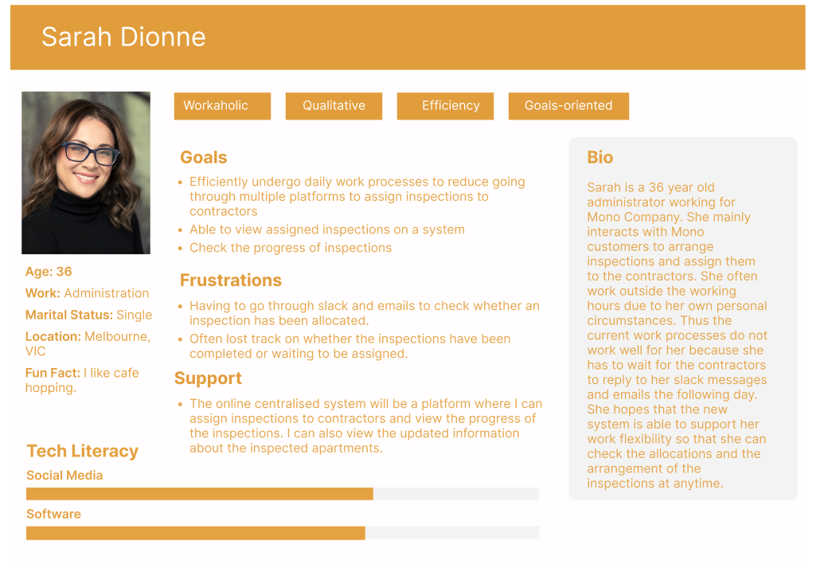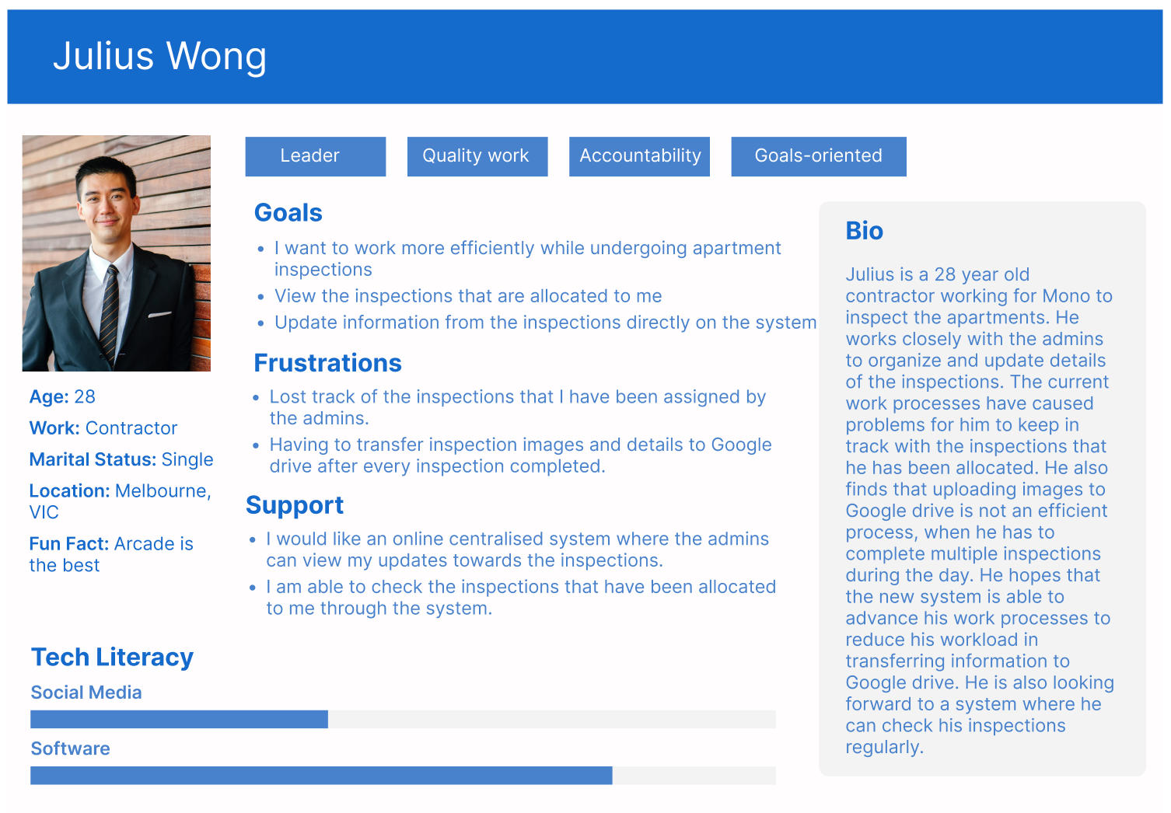

Login Details

| URL | https://production.u22s2110.monash-ie.me/ |
| --- | --- |
| Login Username/Email | Contractor: root1@example.com  Admin: [example@mail.com](mailto:example@mail.com) - pw/ yes |
| Password | team110 |

# Key System Notes

1. Login to Mono system on the login page under ‘Team Member’ at the bottom of the website.
2. Using the given credentials to access the system
3. Sarah is the Admin from the Mono team and Julius is the contractor who works for Mono.
4. Sarah as the admin can view/add/edit/delete the list inspections on the system
5. Sarah as the admin can view/add/edit/delete the users and users’ information
6. Sarah as the admin can view/add/edit/delete the inspection image
7. Julius as the contractor cannot add/edit/delete other users information
8. Julius as the contractor can add images and create descriptions in the inspection page.
9. Julius as the contractor cannot create/delete inspections.
10. Sarah as the admin can create a new inspection which is then emailed to contractors, notifying of a new inspection.
11. Julius as the contractor, can accept an inspection after being notified via email and viewing the inspection.
12. Sarah as the admin can send emails and view email list in the email tab.